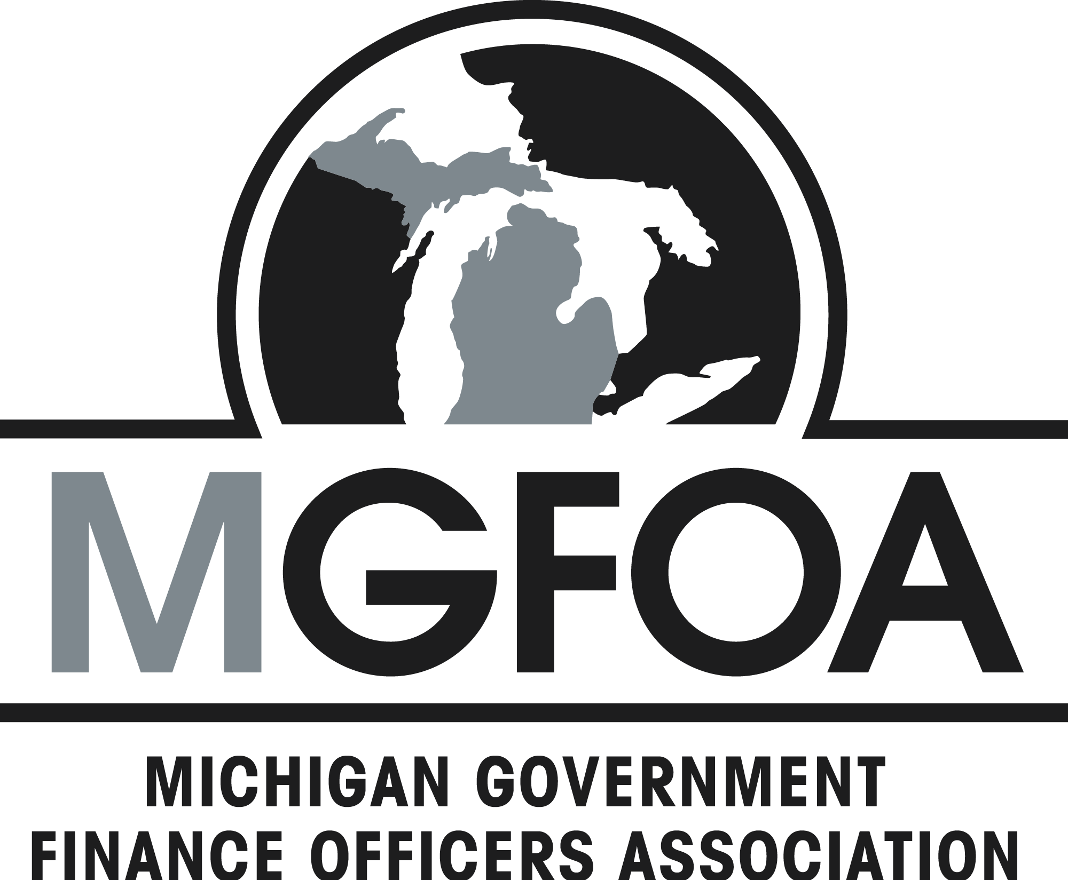
Back to Basics 2018

Okemos Conference Center

I. Fundamental Elements of Governmental Accounting – Training Level: 100 - 200

April 19, 2018
II. Public Financial Statements – Training Level: 100-200

May 17, 2017

III. Governmental Budgeting – Training Level: 100-200

October 3, 2017
Program Overview:
The Michigan Government Finance Officers Association is proud to offer a package of three one-day seminars designed for practitioners in the field of public finance who are responsible for the accounting and budgeting functions in their governmental units. Participants must have had basic accounting and bookkeeping training to enroll in this program.
Certificates of completion will be awarded to participants who successfully complete the series of three seminars within two years. Each seminar qualifies for six (6) CPE or .6 CEU credits. The CPE credits qualify for governmental accounting and auditing.
About the speakers:
Bill Brickey is a governmental audit partner at Plante Moran and Pam Hill is governmental senior manager at Plante Moran. Between them, they have over 30 years of experience in P&M’s governmental group. Both Bill and Pam are CPA's that specialize in serving governmental units of all sizes as auditors and financial advisors.

I. Fundamental Elements of Governmental Accounting:
This seminar will introduce the concepts of fund accounting with emphasis on Governmental GAAP and their applications, as well as the state mandated uniform accounting system for local units. Accounting for Governmental, Special Revenue and Proprietary Funds will also be covered, as will current issues in governmental accounting. The session will include a discussion of GASB 34, its background and elements needed to prepare the government wide financial statements.

II. Public Financial Statements
This program is designed for local officials and practitioners in the field of public finance who are responsible for the financial reporting functions in their governmental units and those who would like to learn how to read and analyze a governmental financial statement. This seminar includes instruction and discussions about financial reporting in Michigan under the requirements of PA 2 of 1968, the Uniform Accounting Act for Local Units of Government. The Government Finance Officers Association (GFOA) criteria for achieving the Award for Excellence in Financial Reporting, including the requirements of clarity, comparability and completeness will be reviewed and demonstrated.

III. Governmental Budgeting
This seminar includes instructions, discussions and samples of governmental budgeting as practiced in Michigan under the requirements of PA 621 of 1978, the Uniform Budgeting and Accounting Act for Local Units of Government.
Topics will include:
- The budget as a policy document
- The budget as an operations guide
- The budget as a financial plan
- The budget document as a communications device
Agenda:
Registration begins at 8:30AM. The program starts at 9:00AM and ends at approximately 3:30PM. Lunch will be served at noon.
Location:
Okemos Conference Center, 2187 University Park Drive, Okemos, MI 48864, 517.381.7300
Registration Policies:
Pre-registration is required so we can notify registrants if unforeseen circumstances require us to cancel or reschedule a
course. Registration is limited, so please register early to reserve your spot.
Confirmations of registrations will be sent via e-mail.
Registering on-line will make this process easier. You may also check the status of your registration by clicking on “View
Registrations” at www.MiGFOA.org. Reservations made by mail, fax, or on-line, unless cancelled, will be considered a
commitment to attend. No shows will be billed, since meeting and meal arrangements have to be made for all registrants.
Cancellation Policies:
Refunds will be made ONLY if MGFOA is notified by April 5, 2018 for Session I; May 3, 2018 for Session II; and September 26, 2018 for Session III. If you have registered and find that you cannot attend, you may transfer your registration to another person. Rates may vary based on membership status. Please notify MGFOA of this occurrence.
No cancellations will be accepted for the package of (3) sessions after April 5, 2018. However, if due to unforeseen circumstances you cannot attend session II or III and notify MGFOA prior to the cancellation date, your registration for that session will be carried forward to 2019.
Special Needs:
If you have a disability and need special accommodations or require a special diet, please notify MGFOA. We cannot accommodate
such requests on the day of the program. Because we are not always able to control room temperatures, please wear layers of
clothing for your comfort.
------------------------------------------------------------------------------------------------------------------------------------------------------------------
Employer ______________________________________________
Name _________________________________________________
Badge name (first name or nickname) _______________________
Title __________________________________________________
Designation (i.e. CPA, CPFO) _____________________________
Address _______________________________________________
City _________________________________ Zip _____________
Daytime Phone (_____) __________________________________
Fax #, if available (_____) ________________________________
E-mail address ______________________________________________

Where did you hear about this MGFOA event? ________________
______________________________________________________
To register online, visit www.MiGFOA.org, or return this form to: MGFOA
4020 Copper View, Suite 130
Traverse City, MI 49684 with a check payable to MGFOA
Telephone: 231-947-0882 Fax: 231-947-2532
One registration per form please

You may register on-line at www.MiGFOA.org
*Note: $5 discount will be applied if you register online
When registered on or before April 5, 2018:

Session I:
□ Member, $95 □ Non-member, $105
Session II:
□ Member, $95 □ Non-member, $105
Session III:
□ Member, $95 □ Non-member, $105
Pkg of 3:
□ Member, $245 □ Non-member, $275
When registered between April 6 and May 3, 2018:
Session I:
□ Member, $120 □ Non-member, $130
Session II:
□ Member, $95 □ Non-member, $105
Session III:
□ Member, $95 □ Non-member, $105
Pkg of 3:
□ Member, $260 □ Non-member, $290
When registered between May 4 and September 26, 2018:
Session II:
□ Member, $120 □ Non-member, $130
Session III:
□ Member, $95 □ Non-member, $105
When registered after September 26, 2018:
Session III:
Michigan Government Finance Officers Association  2017-2018 Board of Directors  President Tamar Lewis, Mass Transportation Authority  Immediate Past President Catherine McClary, Washtenaw County Treasurer  Vice President/Secretary David Keenan, City of Midland  Treasurer Kim Garland, City of Chelsea  Directors  Coline Coleman, City of Livonia  Gretchen Gomolka, City of Brighton  David Helisek, Plante & Moran  Heidi Scheppe, Grand Traverse County  Associate Directors  Thomas Colis, Miller, Canfield, Paddock and Stone, PLC  Jamie Rivette, Yeo & Yeo PC | Professional Development Committee (PDC):  Thomas Colis, Chairperson  Bill Brickey, Vice Chairperson  Robert J. Bendzinski Louis Orcutt  Tonia Betty Jeffrey Pardee  Rebecca Black Brian Quinn  Kamila Dymerski Julie Rudd  Pamela Hill Phillip Saurman  Max Hotchkin Edward Sell Jr.  Richelle Jimenez Paul Stauder  Michael Korsak Benjamin Stone  Kelli Lambrix Thomas Traciak  Tamar Lewis  Irv Lowenberg  Melissa Marsh  Ann Mosley
□ Member, $120 □ Non-member, $130

